**Veka Softline and the Green Revolution**

**Veka Softline is the kind of windows technoloygy that will definitely deliver whatever is needed for passsive buildings - thanks to the construcion based on 7 chambers and extremely thick profile walls, the heat transfer was diminished to a significant level and the insulation is large.**

[**Veka Softline**](https://www.aikondistribution.com/softline-82-md,p315) **as a passive houses building tool**

All of those features really do render Veka Softline product class and perfectly sufficient for whatever conditions there will be and still the passive character of a building will be guaranteed. Want to know more about **Veka Softline**?

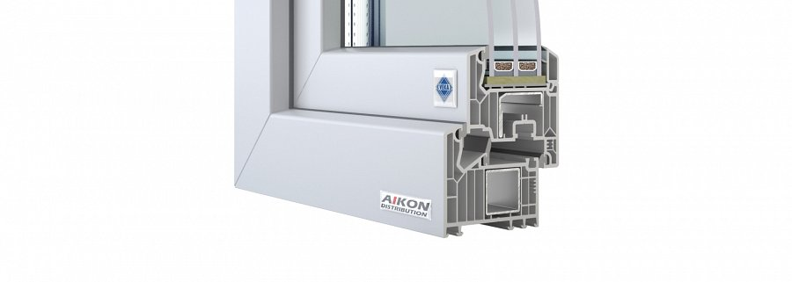

No worries - just check out the website of the distributor - Aikon, namely, as we are proud to be able to represent ourselves with the *Veka* line of the windows showing such technological advancement. And we are also very much interested in supplying whomever wants in equipment perfect for building passive houses or other types of buildings.

**What else? Planet Earth!**

This is our contribution to the green revolution that is occurring right now all around our planet - and it's pretty much high time, since the planet Earth needs it. So wait no longer - start gatering information about passive building technologies and how can **Veka Softline** help you achieve your heattransfer and heat, sound and mechanical energy insulence.

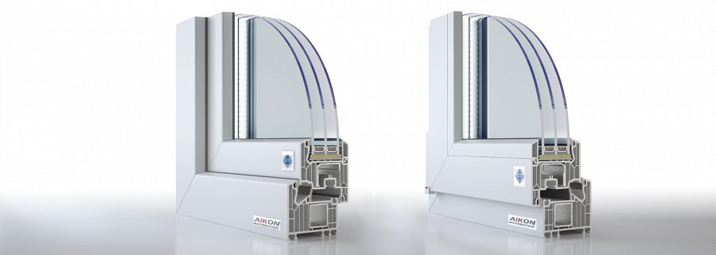

Thanks to the **triple glazed windows**, deeply mounted in the structure of the frame, all of this is really achievable.

More at:

<https://www.aikondistribution.com/softline-82-md,p315>