**Window and Door supplier - details of the business...**

**If you imagine a firm that's a window and door supplier the point is that it's kind of difficult to imagine it small. Therefore, it's also difficult to imagine the first steps you need to take in order to set up such a company.**

**Bit of history...**

And yet - Aikon Distribution was set up in Poland - formally in 2013, but we've gathered over 10 years of experience - and here mostly you start small.



But because when we were designing our *window and door supplier* business, we were thinking big, the situation right now is that we are present worldwide and in several years we are planning that no world local market neither global market in total will be without our voice.

**Window and door suppliers - our voice...**

**.**And our voice is always about the very same - setting new standard, exceeding ourselves and making the window and door supply business offering a better experience for every customer - and that's no matter whether you are a private person, looking forward to living in your own house and willing to get everything buttoned up and your windows and doors only of the highest of quality, or you are a developer, making your living out of providing homes to other people. That doesn't really matter to us - the standard is always the same.

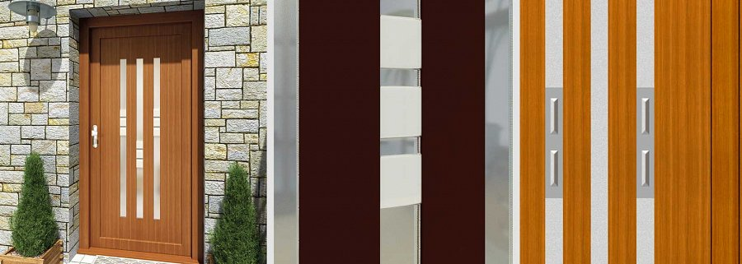

The highest!

<https://www.aikondistribution.com/>