**HPL doors - it's high pressure laminate!**

**HPL doors, such as Sandra line, shown in the pictures, is an opprotunity fo all the kinds of people interested in doors.**

**HPL doors are for whom**

So, those of you who have finishing a house built for yourselves lined up and it's time to pick the type of doors, as well as estate developers, designin an offer for a - let's say, a competition - and willing to convince the jury or whoever gets to decide about whether the investment planned as you would like to, will be launched or not, that **HPL doors** as a single solution in the whole context of the houses planned to be built, is a good one.

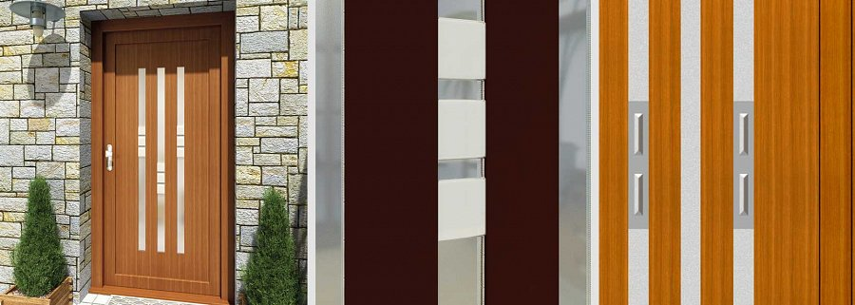

**Here are some hints...**

...that are to show you the reasons why. HPL stands for high pressure laminate. A composite material, designed to be able to cover all the needs, that would a door panel create. That is, thermal expansion, since doors are elements of insulation, especially the doors used inside of the house, that seaparate one room from another.

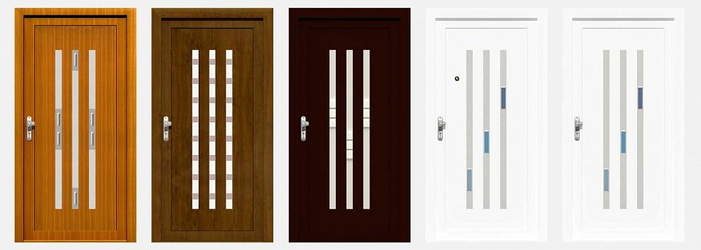

Also, when it comes to entry *doors*, *HPL* ones are definitely fine enough, due to the high level of mechanical strength they exhibit in the tests conducted.

[www.aikondistribution.com/sandra,p235](https://www.aikondistribution.com/sandra,p235)