**Sash window colours - how to choose the right one?**

**On the market you can find various sash window colors, the question you would choose to suit them to your house design? Check our short article.**

**Sash window - fashion from the south**

Colorful sash window can be seen in many southern cities and states. Italy with its popular Positiano or Sorrento, Malta or Portugal where to Proto, Lisbon and Faro to see colorful buildings and sash windows in many colors of the rainbow, tourists from all over the world come. Spain and even Croatia or Montenegro are famous for their love of green or blue sash windows. **Sash window colours** creates an amazingly beautiful landscape and makes the house remind us of holiday, southern atmosphere.

**Sash window colours for modern houses**

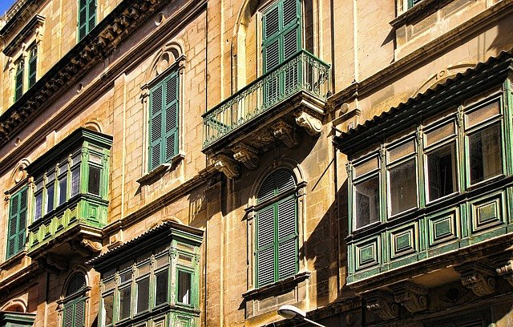

Also in modern house designs, sash window colors can be used as a decorative element that will make the house stand out from other buildings. Where to buy [**sash window colors**](https://www.aikondistribution.com/colours,p314)? In the offer of the international Aikon Distribution company, you will find an assortment that you will certainly easily match your home design. Blue, brown and black are available, among others. Check out the full offer on the Aikona official website.