**Aluplast doors system - how can it help your house?**

**It's not just a matter of home improvement only. Not a mere effect of a makeover. No. It's something more. What is this "more" when it comes to Aluplast doors, you may wanna ask? No worries, we can give an answer in short. Just keep reading.**

**What's the deal?**

This blog is all about technology. Its sole aim is to present various products that are distributed by Aikon Distribution company not as products themselves and only limited to being products - with their prices, advantages and disadvantages, but as technologies.

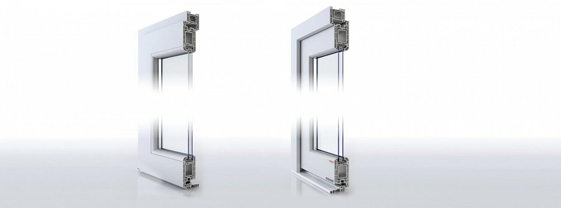

As innovations put into the mass production and therefore opprotunities for those of you who want to make a makeover in your houses but are not only necessarily interested in making ot only superficially.

**For whom Aluplast doors are?**

For those of you who are interested in windows no more, but in doors for instance, there is a first signal - *Aluplast doors*. Those are - a little bit as other lines that were already presented in this series - designed carefully and the materials for their manufacturing were carefully selected for their physical properties.

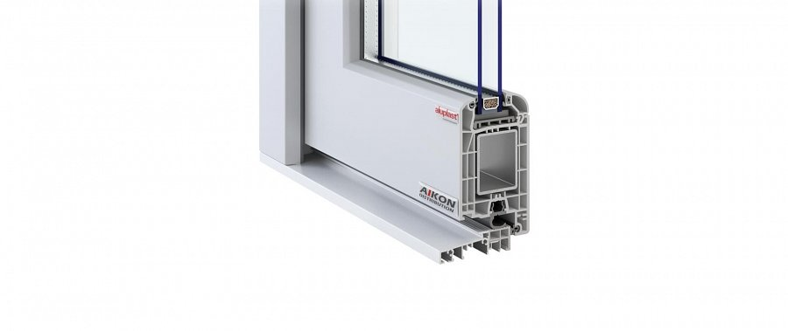

The goals of **Aluplast doors** designers were clear, though. They were to be universal - the technology has to guarantee durability and allow possibility of adjusting the doors to the custom, individual conditions. And this is fully what those doors do. Wanna know some more of it? Get to the page and read the detailsed information!

<https://www.aikondistribution.com/front-doors,p89>