**Shuco windows - a German standard**

**Sometimes the phrases of nationalty plus a boast are completely empty - they have become such, probably after being recognized as an almost free marketing material. But when it comes to Shuco windows, especially the SI82 RONDO line presented today, it's all hands down, really.**

**One thing only - and it works!**

If you are looking for the top of the possible quality windows, there is a method. Simply look for those which are desgined for passive houses - or zero-energy houses for that matter, but passive buidling is a more wide-known philosophy of buidling, and it's in line with a whole certain lifestyle, that' really alive in Germany.

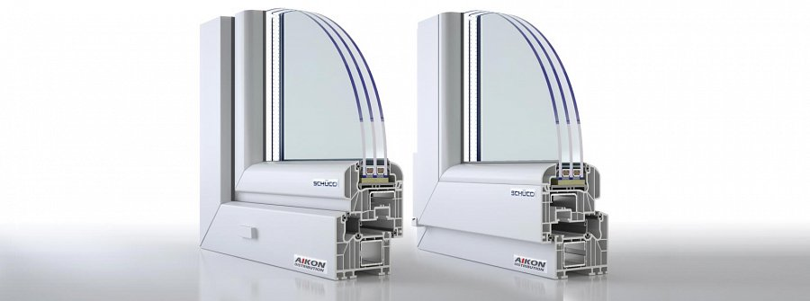

The point is to limit the thermal exchange between the interior and the exterior of the house and thus be able to avoid generating too much energy in order to keep it warm inside. And if a house is additionally equipped with small scale green energy devices, such as photovoltaics units, it's a green dream come true.

**With Shuco windows looks matter too!**

**Shuco windows**' aim to help one achieve this. Within the material, its application, the design, a cutting-edge technology was used.

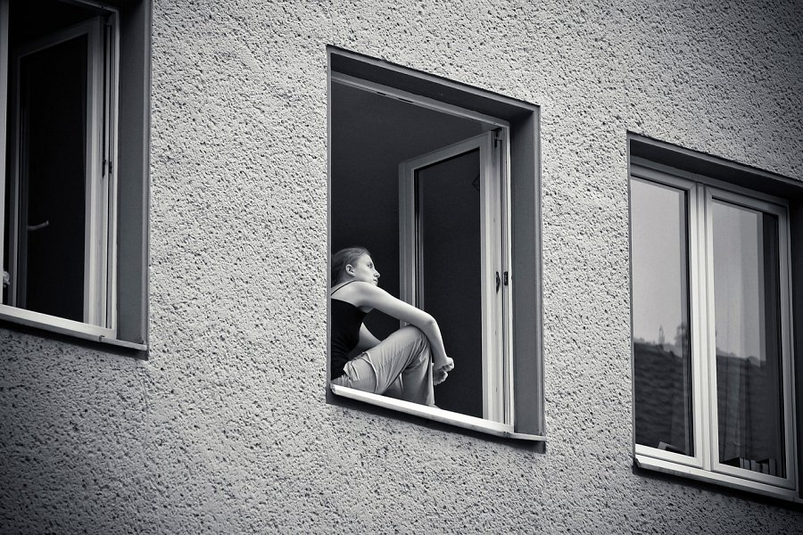

Also, triple glazed glass used in the windows additionally makes them more resistant to the powers we'd like to stop. Last, but not least, since a house needs to be something we can boast with, Shuco windows are designed in a neat, cool way. See them yourself!

<https://www.aikondistribution.com/si82-rondo,p19>