**Quality uPVC windows**

**Looking for quality uPVC windows? Not only "no worries", but also "look no further". No, it doesn't mean that we are about to offer you a new solution, perfect for any application, since a thing described this way simply does not exist. But we are about to offer you a hub. And that's what it's all about today. It's not that you can strike oil - but knowing a local who's gonna show you where it's most probable to strike it is something that should be qualified as truly worthy.**

**Our name needs to mean somethinig....**

Therefore, we'd like to show you our services - Aikon Distribution - doors and quality uPVC windows supplier - we are the hub we mentioned above.



We work hard to - firstly - assemble the best manufacturers from all over the world - it's mainly Europe so far.

We'd like to offer not products by anyone, but only by the most trusted ones - in order to make our own brand also mean something when it comes to buying doors and high quality uPVC windows for euther your own house or for a multiple usage in a development, like a set of estates.

**A simple conclusion**

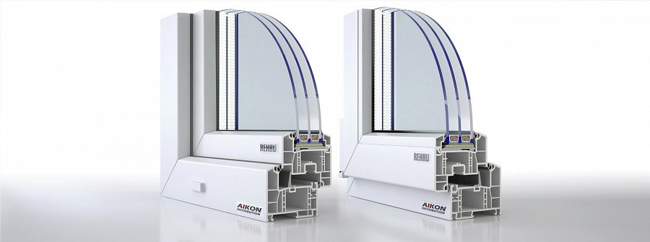

Doesn't matter - we want only the best ones.Check us out!

<https://www.aikondistribution.com/ct70-classic,p14>