**Aluminium lift and slide doors**

**In our article you will find some pertinent comments about the finish of the house and about aluminum lift and slide doors.**

**Doors and others important elements**

When choosing equipment for your home or apartment, the first thing we think about will be aesthetic values. That is, that all elements such as doors, windows, radiators or lighting match the color of the walls or furniture, which we see in the imagination, in their spaces bedroom or living room or office. Nevertheless, the functionality of these products is equally important! A [aluminum lift and slide doors](https://www.aikondistribution.com/ultraglide,p377) is one of those doors that will combine good looks with good quality and functionality!

**Aluminium lift and slide doors from Aikon's Distribution offer**

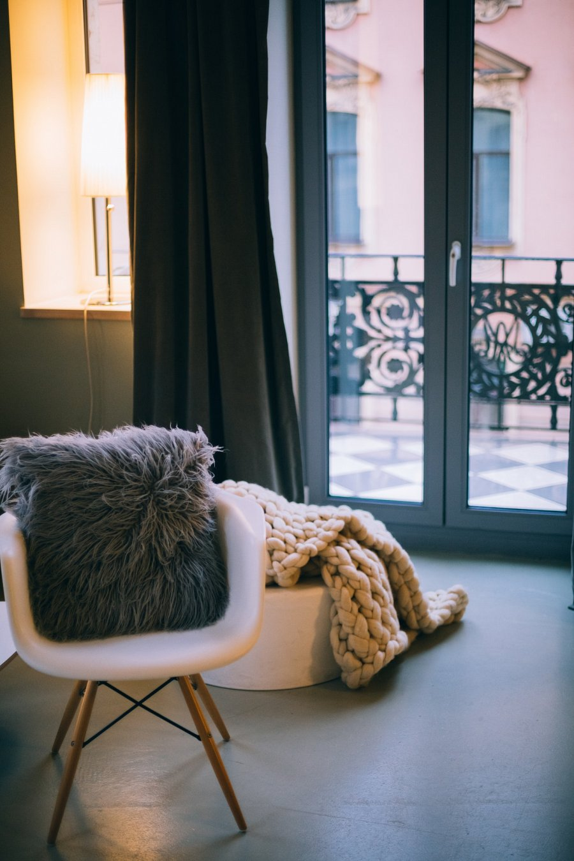

This door model can be successfully used, for example, as a transition from the living part to the balcony or terrace in your apartment or at home. **Aluminum lift and slide doors** are safe for doors that will keep the temperature in your apartment and also isolate residents from noise outside the building. This type of door will also work in office spaces