**Slide Plus doors | www.aikondistribution.com**

**Slide Plus doors - a solution for you house, made for you by Aliplast and also available withing the framework of Aliplast system, but then brought to you by Aikon Distribution.**

**Slide Plus system properties**

Let us say today a few word about why do we love thisproduct and why we recommend it to anyone looking for sliding doors for his or her house or any other type of building, including corporate, instiutions etc.

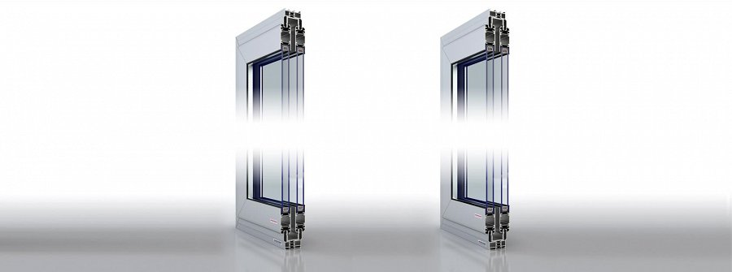

First of all, the **Slide Plus** technology supports high performance heat insulation. This is thank to the three chamber frame and one chamber door. the solution applied here, together with the materials used - and it's aluminium - with 24mm infill, the heat can be prevented from escaping a given space and therefore the bills for making those spaces comfortable for humans who might want to spend some time in there.

**What about the looks?**

What is even more interesting for those of you who want not only economical or green value, but need also aesthetically good looking place to live, the news from Aikon Distribution will be great to hear.

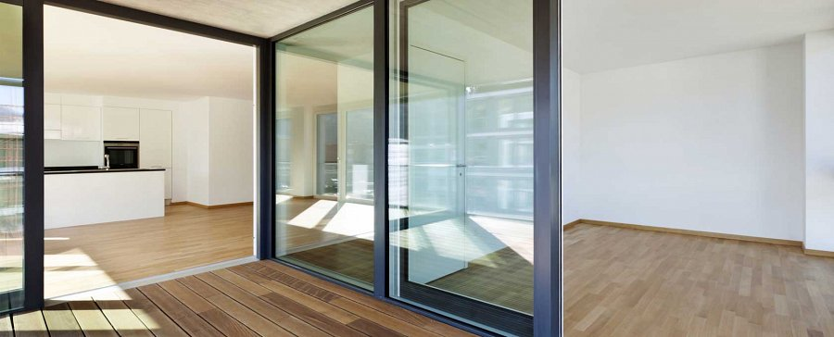

When it comes to *Slide Plus* doors, supply from our side is complex and holistic - which means you can order custom bespoke windows and doors, with your own measurements, the sash colours you would like to see and so on and so on.

[www.aikondistribution.com/slide-plus,p62](https://www.aikondistribution.com/slide-plus,p62)