**Aluplast doors - and other accessories...**

**Sometimes you think about the house as mostly the foundation, the concrete walls, etc. And windows, doors, etc. this is merely the filling of the necessary walls - you need a lot of light, decent insulation, and a good design and that's about it, right? Well, possibly, but on the other hand, that's short term thinking. What is long term on the other hand? Well...**

**Long term thinking - eco-focus!**

Long term thinking about a house is to focus on insulation. To build a passive house, it takes to think about the windows and doors as much as about the walls, etc.

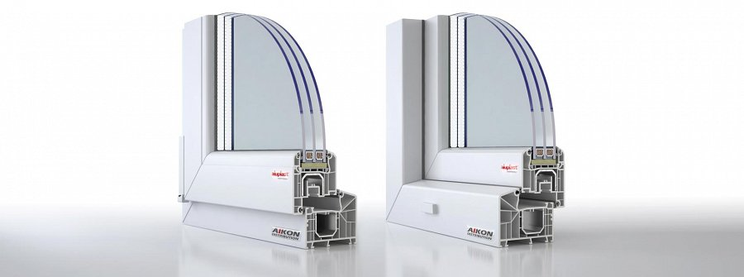

And it also takes a lot more funding, but that's at the outset. On the other hand, a lot of people have houses already, and how about that - how to make them come a little bit closer to the point where they have a house that's actually helps in monthyl savings, and is more ecologically friendly.

**Aluplast doors and windows!**

So, accessories like Aluplast 4000 windows profiles, additionals for the window frames, are there to be right in. So, don't hesitate!

[aikondistribution.com/id-4000-new-85,p83](https://www.aikondistribution.com/id-4000-new-85,p83)

