**Veka uPVC | windows for passive houses | www.aikondistribution.com**

**How can particular windows - just like Veka uPVC - Effectline for instance - help you with your building plans altogether? They can, of course - we will now explain how.**

[**Veka uPVC**](https://www.aikondistribution.com/effectline,p26) **- what can you gain?**

**Veka uPVC** window technology is a special solution for all of you who would like to boost the energetical parameters of a house. How to do it, though? Decreasing heat loss is one idea - the amount of energy that leaves abuilding through various cessations of isolation can be grave.

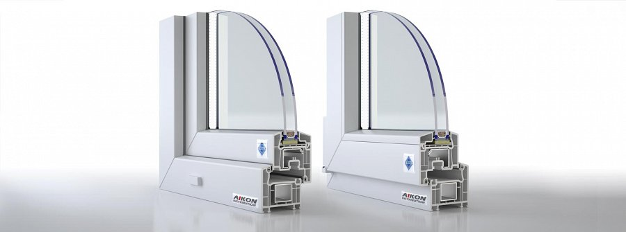

And this creates the everyday reality of a person who will choose to live in a place, or will be, at least partially, made to do so. This can be changed, though.

**Also... what else?**

*Veka uPVC* windows, alongside other window insulation technologies helps you create a quite different environment - something that is likely to change the economical reality of a house altogether - passive house, or houses that yield maximum energy loss diminishment.

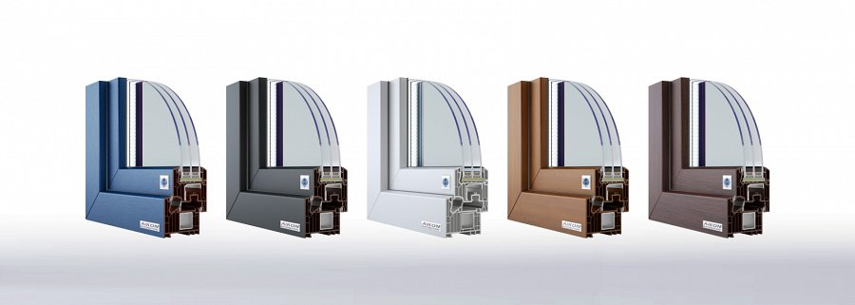

With Veka uPVC you willl be able, at the end of the day, to save a whole lot of money and a whole lot of energy - this will help your individual budget and will help the environment too.