**Aluplast - a brief technology description**

**Good design, production and then distribution can serve as the keys to the modernization of the whole infrastructure. This is the kind of systemic thinking that we - in Aikon - would like to apply for our services and we are thrilled when we meet customers who also would like to be in line with this vision.**

Therefore we are especially proud to present **Aluplast** - a comapny providing window and door technologies.

**What's Aluplast?**

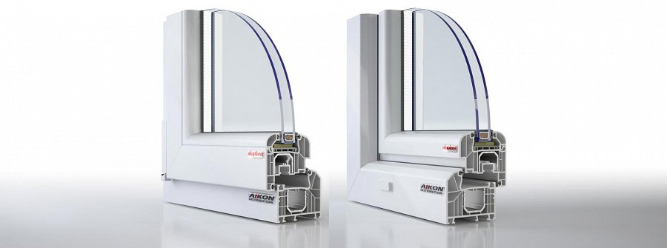

Technology solution that *Aluplast* brings us is both a firm standard guaranteeing an excellent efficiency in several key parameters of window performance, such as heat exchange with the environment of the house and many others. But on the another - it's a system that can be applied to many types of windows.

**Let's say.... let's imagine the windows working!**

Let's say a neighbourhood is being developed - and a series of estates are to be built in an area, but their design is absolutely original - and the windows that are needed now are triangualr, trapezoidal and whatnot - the costs seem to spike, no?

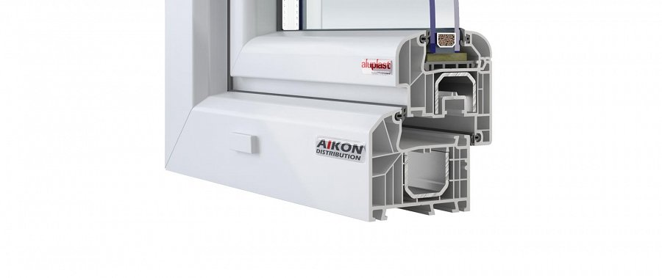

Not necessarily - becuase Aikon Distribution is a long term Aluplast partner and we know the system inside out, we can present the full possibilities of the shapes of the windows you can get - with all technological benefits, of course!

So why wait? Check us out!

[**https://www.aikondistribution.com/id-7000rl,p82**](https://www.aikondistribution.com/id-7000rl,p82)