**Veka composite doors for finding perfect balance of costs and offered features**

**Are you in charge of special products choice for an upcoming real estate investment, and there are many needs to be met, all of them simoultaneously, preferably, by choosing such products that would satisfy a diverse palette of needs from different standpoints?**

**Veka composite doors for optimization the costs of an investment**

So, if you are therefore looking for windows or doors for a construction project, we're here to help you, by providing consulting in the subject matter, as well as straightforward sales.

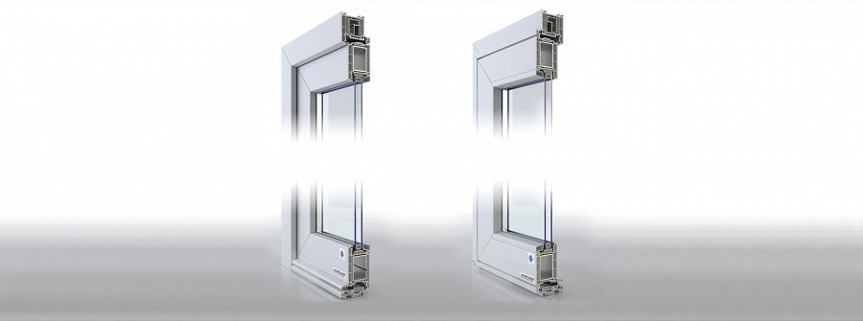

**Veka composite doors** is a one thing we'd like to show you this time. It's a great choice for all of you who are seeking a product that'd be customizable, therefore yieldnig possibilities of tailoring it to the vision of the desginers.

**The tech insides are dope, too**

Also, it's an advanced technologically product, with solutions focused on good thermal insulance, and security from both nautral phenomena, and the unauthorized access to the house. For more info on **Veka composite doors**, please see the dedicated product page on the *Aikon Distribution* website.

On top of all that, in need for more detailed info on particular products or in general, give us a call or write email, we'll get back to you quickly: [www.aikondistribution.com/front-doors,p35](https://www.aikondistribution.com/front-doors,p35)

