**HPL door - a solid topic**

**It's a solid topic, because it's simply an important one.**

**HPL door - high pressure laminate-made**

Doors - they, together with windows, keep us away from the world, creating privacy. Separation is not necessarily an idea loved by everyone, but it has its place - just like privacy, which, by the way, is a word derived from "lack of".

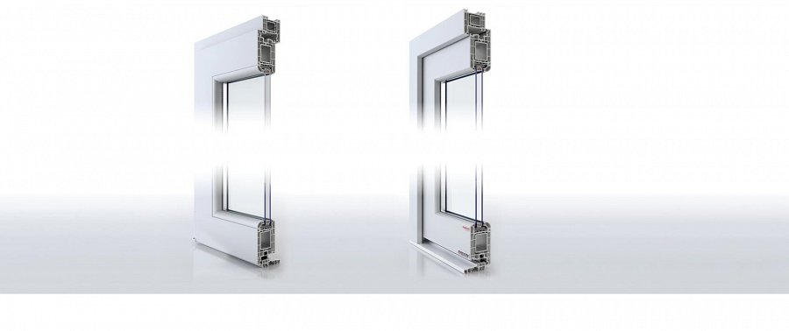

**HPL door**, the name points out to the manufacturing technology - high pressure laminate is how they're made, and that may be a cause for concern - since laminate, for non experts, but people nevertheless aware of laminate popping up here and there in various home appliances as their material, does not necessarily bring out trust in high firmness and mechanical strength.

**Concluding**

And yet they are, and they do - *HPL doors*, no less - provide a solid and not unfounded sense of security for homes and people living there. And their looks are also their advantage. And that, together, seems like a reason enough, to get interested in those doors.

click here for more info: [www.aikondistribution.com/sandra,p235](https://www.aikondistribution.com/sandra,p235)

