**BluEvolution 92 for Green Revolution!**

**When it comes to passive houses and the numerous products that are required for them to be actually functionable as passive houses, in other words, as they should - a very specific need for a product arises.**

**BluEvolution 92 windows model**

These are windows for passive houses, and usually are uPVC windows. Today we'd like you to see a single model from this type - **BluEvolution 92**.

Those are windows manufactuerd by Salamander, and as the name suggests, the manufacturer wishes to tap into a stream of revolutioary thinking about technology and ecology, which, under the term of sustainability, is currently trending in building and architecture.

*BluEvolution 92* is therefore a set of window profiles dedicated for low eneregy buildings, therefore definitely passive houses, then.

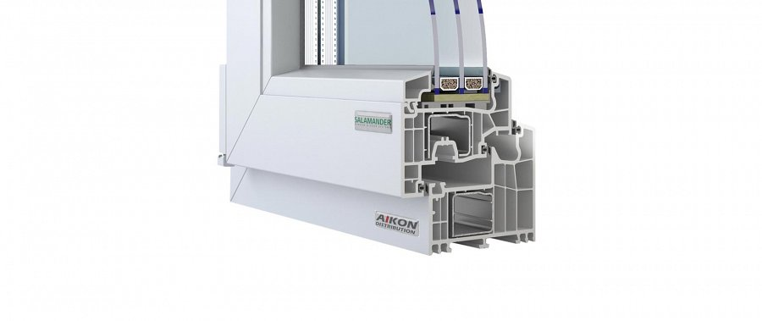

**It's not all - keep reading**

And it does not stop there - even for a house that has no intention to be passive or a zero energy house, those well insulated windows will mork miracles, anyway, keeping the energy from disappearing.

If you feel interested in those, please see the in depth description by clicking the link enclosed:

[www.aikondistribution.com/bluevolution-92,p349](https://www.aikondistribution.com/bluevolution-92,p349)

