**What boosts the worth of your house**

**Well, generally, nothing like a makeover. But in order to get the most of it, you need to invest thoughtfully. Not all makeovers will return as a significant increase in house worth.**

**Passive houses are like ideals**

But those that take an older house closer to the energetical ideal of a passive house, thus allow better terms whne it comes to insulation, and energy loss prevention, generally do pay off.

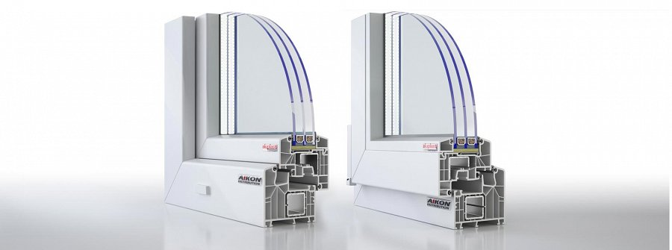

What types of makeovers are these, anyway? Well, the simplest ones, the ones that do not necessarily require a deep intervention into the structure of the building, are installation of new windows and doors.

**Aluplast 8000 for a passive house**

Currently, there are numbers of uPVC windows - such as **Aluplast 8000** that are specifcally designed for passive houses. So, the effect of installing them in the building that you own, is that the energy loss will drop, and the bills, too.

So, it's gonna all go better, and in longer term, living in such a house will be more affordable - even though investing in *Aluplast 8000* is, how it's called - an investment.

Here for more details:

[www.aikondistribution.com/id-8000,p84](https://www.aikondistribution.com/id-8000,p84)

