**Aluplast doors - a fundamental detail**

**In what way can we talk Aluplast doors in an interesting manner. Well... Imagine a neighbourhood, being erected. All the way down, from the foundations, deep in the ground. What is a sign of it being ready - what sort of accessory can signify that the work is done and new owners or tenants can move right in?**

**Aluplast doors - a complex advantage**

There is saying of a house being built in such a way that only a key needs to be used. It means that no makeovers are needed and the house is pret a porter - well in this case it's not porter per se, but living there, but the meaning stays the same.

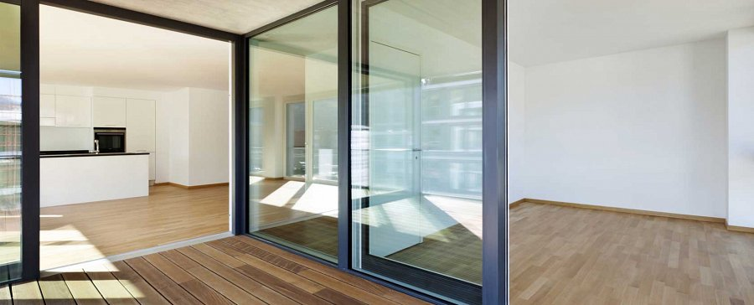

**This is then a cornerstone detail**

Anyway, it's the doors that we spoke of in the lead of this text. such as **Aluplast doors**. The last detail.

And yet, as fundamental as a cornerstone. Ever saw a house with no doors? Might have been Japanese, but they have doors too, but in a different form, of movable walls to be precise.

*Aluplast doors* will do perfectly as this last detail.

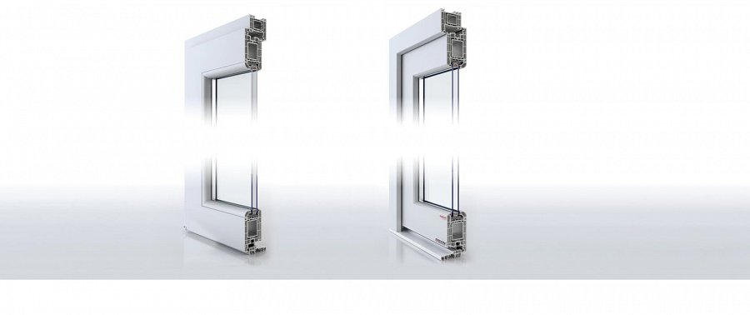

See more of them here:

[www.aikondistribution.com/front-doors,p89](https://www.aikondistribution.com/front-doors,p89)