**German uPVC windows | aikondistribution.com**

**Need some information on windows for passive houses? Well, be our guest, now!**

**German uPVC windows for passive houses**

Currently, the philosophy behind building houses changes - more and more is stressed on the topic of ecology, which is sometimes called as sustainability, ini order to emphasize also the economical value of ecological thinking. For instance, the models you may just be looking for around, are some *German uPVC windows*.

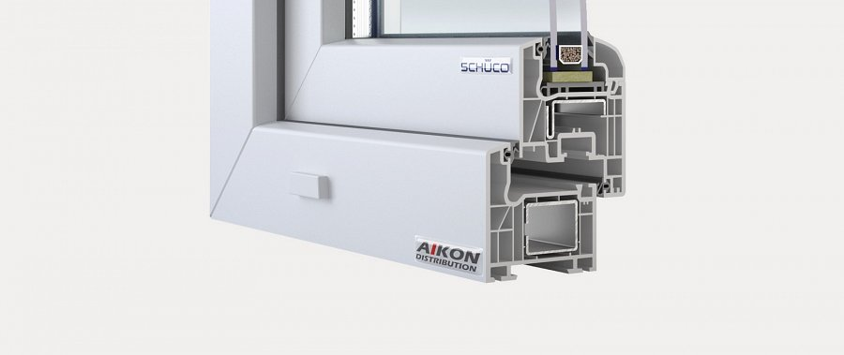

But that requres not only change in the minds of the people, and also not only in policies, supporting those who wish to build a house for themselves, that would be an effective, passive building. Also, we need a different industry - a one that would be able to offer the elements required for sustainable living to the masses. And currently, that thing exactly, is, you may wanna say, missing.

**Aikon fills the gap**

But here comes Aikon, filling that gap. With our windows and window frames technology for passive houses. Among these prodcuts and accessories, **German uPVC windows** are ones of the most interesting, owing it to their production standards, never failing.

So, if you are interested in further information on German uPVC windows, please click the link below:

[www.aikondistribution.com/ct70-classic,p14](https://www.aikondistribution.com/ct70-classic,p14)

