**Aluplast doors - for large construction projects!**

**Construction industry hasbeen booming for years - there was some gully before, but there is still a lot of work to do in that field.**

**The construction potential of Aluplast doors**

And the finest job of a real estate developer there is is to maintain a standard of reliable construction and interiors, if provided for the inhabitants in spe. Fo instance, when it comes to entry doors, no better choice than *Aluplast doors*.

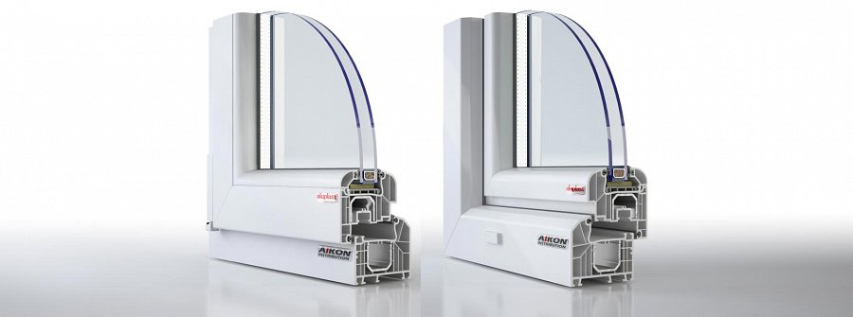

Doors by **Aluplast** offer several core features, qualities that are more than enough to secure the whole investment- door-wise, of course. With support from **Aikon Distribution**, it's easy to get in touch with the manufacturer and prepare the doors talored to our ideas and needs - just as it was designed in the plans of the estate to be erected.

**Tech-wise Aluplast product wins, too**

Also, from technological point of view, **Aluplast doors** are also smashing - however, for more details, it'd be better to simply refer you to our dedicated Aluplast doors landing page, or our consultant, who'll be happy take your call, and inform you on whatever's necessary in terms of product information:

[www.aikondistribution.com/front-doors,p89](https://www.aikondistribution.com/front-doors,p89)

