**Ultraglide sliding doors - best patio doors**

**Wondering What to choose on your terrace or balcony or patio?**

**In our article, we present a few tips on how to choose the right door, we also check the model ultraglide sliding doors.**

**Glazing in architecture**

Glazed rooms are definitely one of the architectural trends both in the design of buildings intended for offices or other work spaces such as show rooms, restaurants, bars or clothing or electronics stores. Also in the case of designing a residential house, many people decide to use not only spacious and large window profiles, but also glazed balcony or terrace doors. Why do we decide to make our house so visible to outsiders? Promoted fashion for a spacious apartment, which lets in a lot of sunlight was initiated in the United States and also in the Scandinavian countries, where modern and ecological buildings were just designed in this way and then fashion also went to other countries.

**Ultraglide sliding doors - one of the balcony doors**

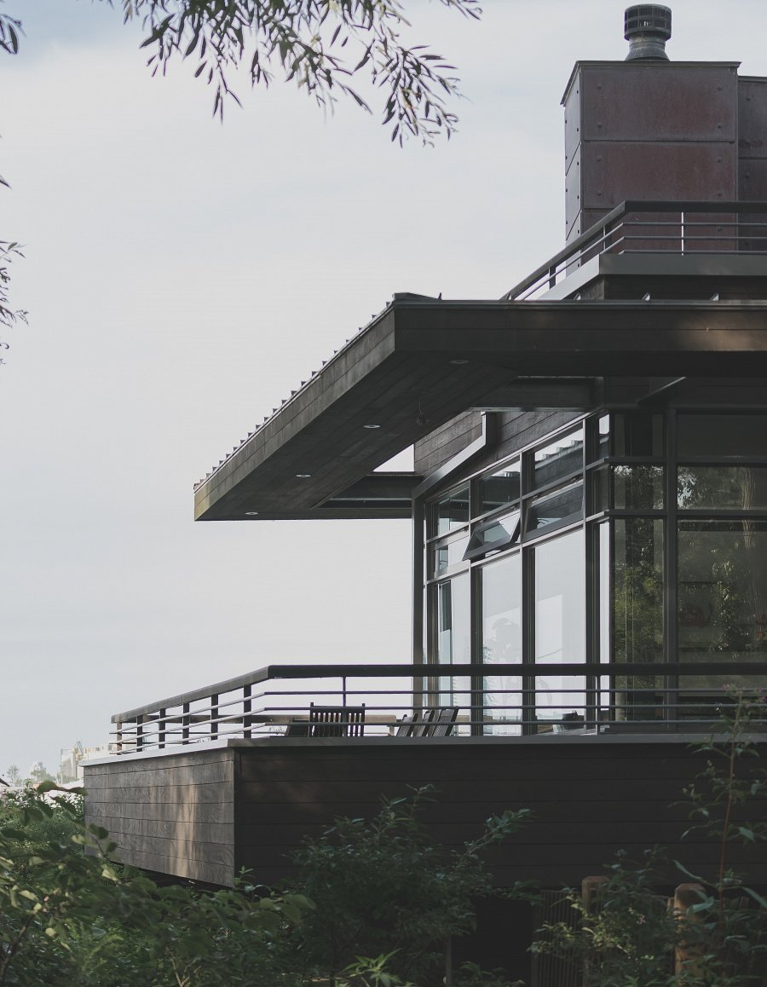

On the market there are a lot of models of balcony doors or terrace doors, which can be successfully used in small spaces, while [ultraglide sliding doors](https://www.aikondistribution.com/ultraglide,p377) made by Aikon Distribution is dedicated for a large glazed corner applications, perfect for commercial or modern apartment buildings. So if you are looking for modern doors that were made based on the latest technologies available in the construction industry, it is certainly worth to be interested in Aikon Distribution offer and products like **ultraglide sliding doors**.