**Aluplast doors | www.aikondistribution.com**

**This time, in our series of article we won't refer to any windows. Let's assume that the windows we already secured and let's move on to the doors! Aluplast doors made of PVC, which is a material well known for us, since many windows we already presented were made of it.**

This time, in our series of article we won't refer to any windows. Let's assume that the windows we already secured and let's move on to the doors! **Aluplast doors** made of PVC, which is a material well known for us, since many windows we already presented were made of it.

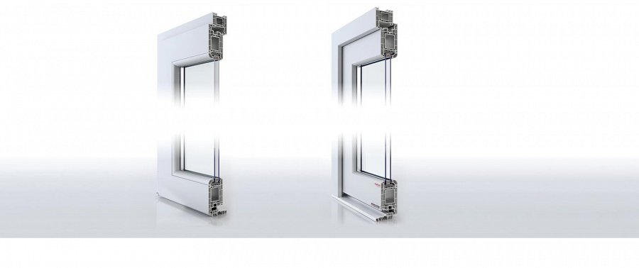

**What about the Aluplast doors then?**

However, as for the doors, the requirements are different, The construction as well. Doors do not take so much space in the whole house construction, so when it comes to ecological reasons connected with energy bills spending etc., they are, of course, quite important, but not as much as windows.

**Their durability...**

On the other hand, doors are considered to be a sort of a gate to your own house, so what your require of them are mainly two things - durability and being able to represent the interior though their looks in the exterior. So what you need it a guarantee of durability on one hand, and aesthetical value on the other.

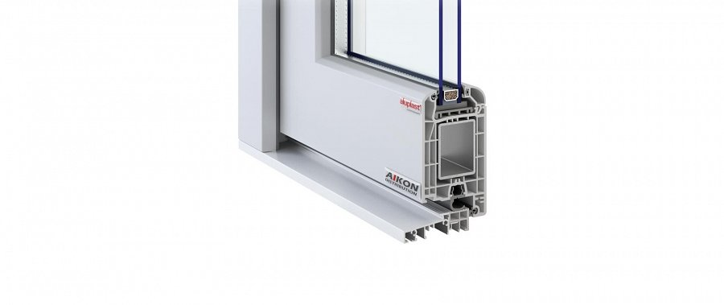

For thie first one, a special construction of *Aluplast doors* system will be of a total guarantee that this will work. On the other hand, multiple range of colours allows you to pick the one you think will suit the best!

<https://www.aikondistribution.com/front-doors,p89>