**Aluplast profile window from AikonDistribution.com**

**Thinking about getting some quality windows - either for your brand new house, or if you are currently conducting a makeover, this is a chance for you.**

**Aluplast profile for your house**

If you haven't come across , now's your chance to learn more about this battle proven brand of low energy building windows designer and manufacturer.

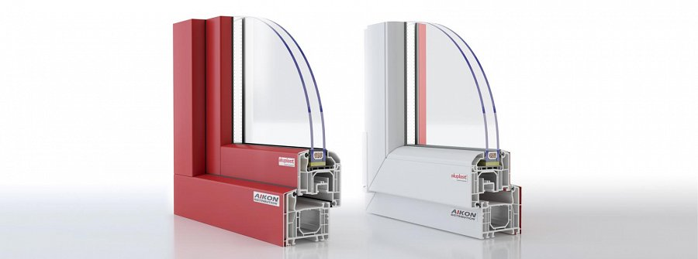

Aluplast profiles, for instance a model Aluplast Ideal 7000, is pretty well adjusted for both classic facades, and the modern buildings. The shape of the sash makes it possible to find a design that will be a perfect match, regardless of the potential setting.

**Seeking quality uPVC windows?**

By getting *Aluplast profiles*, you will be able to get some both solid intention for your house, and durability of windows, sothey could last for the next years, withstanding even the tough weather conditions, and such.

So, if the features mentioned above seem appealing to you, and you want to learn more about the brand, and the available products, please learn more about Aluplast profiles, by clicking the link below:

[www.aikondistribution.com/id-7000rl,p82](https://www.aikondistribution.com/id-7000rl,p82)

