**Sash window colours - make the front of the house shine!**

**When it comes to a house, windows serve as a kind of eyes - they are fully representative. Since we've done so much writing on windows technologies here, it's time for something less serious...**

**Sash window colours** and palette - something therefore more vivid. What do you think about that?

**What are sash windows at all? Why colours?**

Let's start with the basic things. We have not yet explained what are sash windows - and it's simple and most of your probably have already seen them somewhere.

They add a lot of class to a house - these are windows with moving compartments - sliding from uppper part of the window in the downward direction.

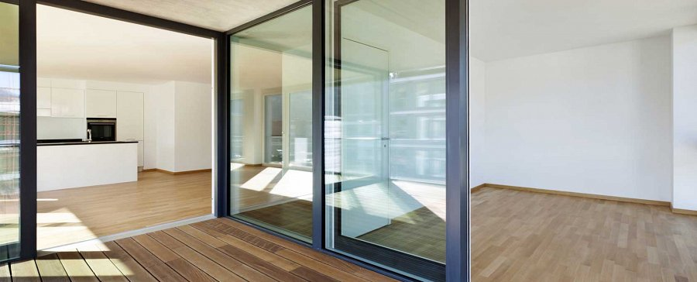

And this is the thing - it allows so many options too with the colours - **sash windows** make a perfect opportunity, since the colours of the veneers can fit the general, overall tonation of the house in terms of harmony, or on the other hand, if you want to go hardcore aesthetically, can be of a planned disharmony and contrast, but nevertheless the *sash window colour* has to be picked rightly.

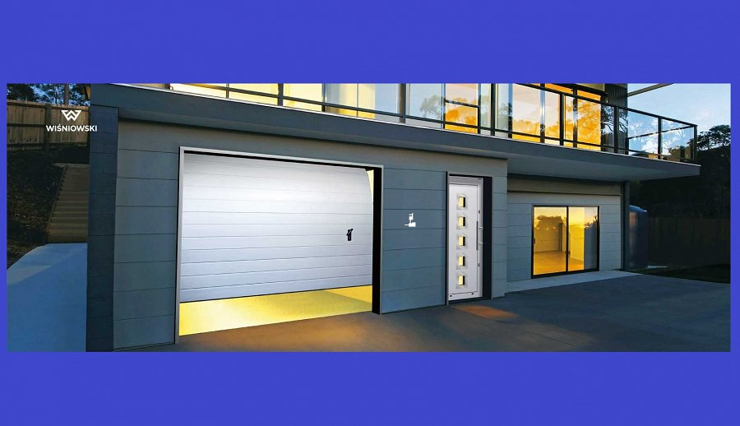

**Concluding...**

So wait no longer - check out the offer of Aikon Windows and try out what palette we have and what fits you well!

[www.aikondistribution.com/colours,p314](https://www.aikondistribution.com/colours,p314)