**HPL door - material matters and how does it**

**HPL door is an interesting artifact, actually. What do we mean by this? It's a set of completely inconspicuous door set - perfect for separating indoors from the outdoors, nicely composing with an equally nice porch. But obviously they are in some sense unique, otherwise we wouldn't be speaking of them in this manner, right?**

**The structure of HPL doors**

Answer is pretty simple, but opening pretty fascinating - nomen omen - doors - the material. HPL is an abbreviation taken from "high pressure laminate" and there are but 3 main aims for designing and applying this materials in doors.

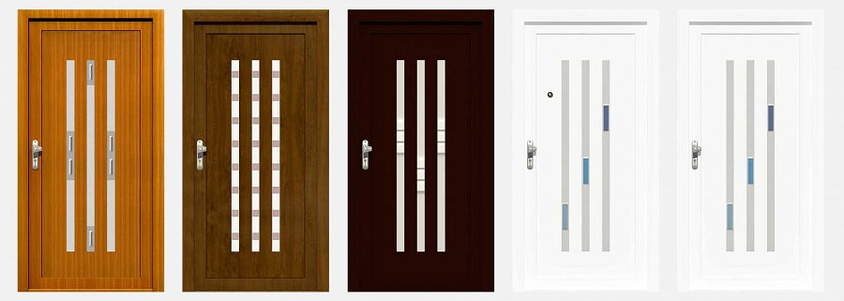

But before we'll mention them in more detail, let's discuss what is **HPL door** made of, really. It's a heat-reactive resin laminated together with paper and then the panels are made of it and then the panels are assembled together, pricessed and the door set is ready.

**The aims**

The first one of the aims we've mentioned above is arriving at the limited thermal exchange, helping to keep the bills down.

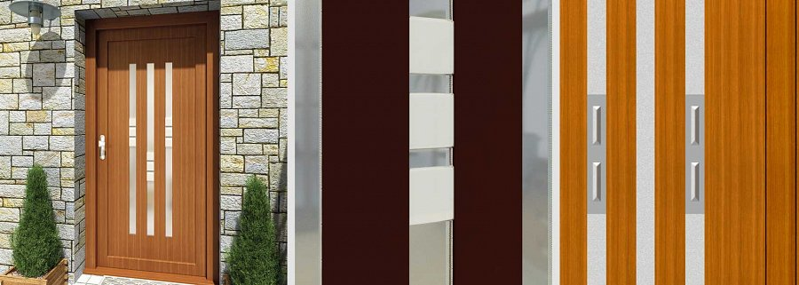

The second here is to guarantee mechanical resistance for years - to not allow the doors be damaged by no small, everyday event, thus making them appear more and more used throughout the years.

Third is a thing partially mentioned - HPL door set is thought to serve throught the years - sustainability and quality!

See more: <https://www.aikondistribution.com/sandra,p235>