**Rehau Geneo - more system than a mere window**

**Rehau Geneo - windows that are called a system. Why? Because of their design and structure.**

**Rehau Geneo - several facts**

They are made in such a way that the *Rehau Geneo* windows can provide a heat energy insulence near to perfect, which is needed when a developer or a person decided to build a passive house - so a one that offers a relative independence from the energy sources.

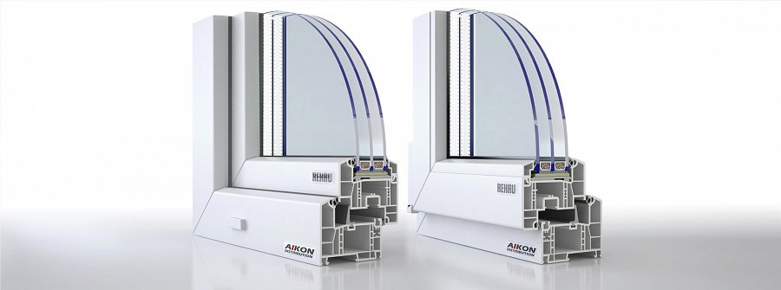

The whole amount of the energy needs to be kept inside of the building. And the windows are usually those, so to speak, knots, of the network of elementes serving as sites of an exceptionally intensive energetical exchange with the environment.

Hence, **Rehau Geneo** are made of special material, additionally supported by fiberglass. On the top of that, there is a uPVC coating. Those three materials, working together, aim at guaranteeing a drop in the amount of energy that is being basically lost by the house.

[**www.aikondistribution.com/geneo-md,p39**](https://www.aikondistribution.com/geneo-md,p39)

This happens usually, with the most constructions, but then the rooms of it become like an endless pit, so to speak. They always need an energy consumption in order to keep them warm enough. So for the colder climate passive houses seem like a perfect, sustainable solution. This is *Rehau Geneo*!

