**External roller shutters**

**In our article, we suggest what to look for when choosing external roller shutters. If this topic interests you, we encourage you to read.**

**Windows and shutters**

Considering the trends that currently exist in interior architecture, it can be seen that large windows are of particular interest. We want the space of our house or flat to be well exposed by natural light. In addition, large windows make the bedroom, living room or kitchen seem larger. Nevertheless, in warm months, wide and high windows have their drawbacks. One of them is the fact that the rooms heat up very quickly, so the temperature in them is high and often uncomfortable. The solution to this problem may be the installation of [external roller shutters](https://www.aikondistribution.com/blog/what-roller-shutter-to-choose-for-your-home-guide-of-roller-shutters,27).

**External roller shutters**

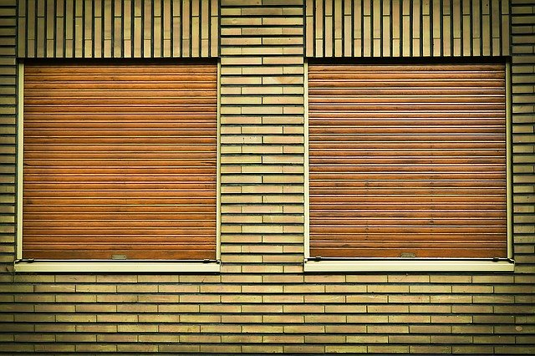

When choosing external blinds, it is worth paying attention to a few details. One of them is color. This is especially important for buildings that have already been built. Remember that the blinds are mounted outside, so they must match the color of the facade to make the whole project look good. Another option is **external roller shutters** attached to the window. Nevertheless, this option works only if we want to replace all window frames. If we are lucky that we are building a house from scratch, it is worth paying attention to window covers that are built-in, so-called flush-mounted.