**Rehau Geneo - what's the deal with these?**

**Some windows are not windows only, actually. They are more than that - they are technology. And the profit for an end user from them being advanced and carefully designed is plenty. For instance, you are then able to put such windows in your house or flat and increase thermal isolation of the space you occupy.**

**Keeping the heat in - Rehau Geneo**

**Rehau Geneo** is a technology for windows leading to excellence in eneregy efficiency.

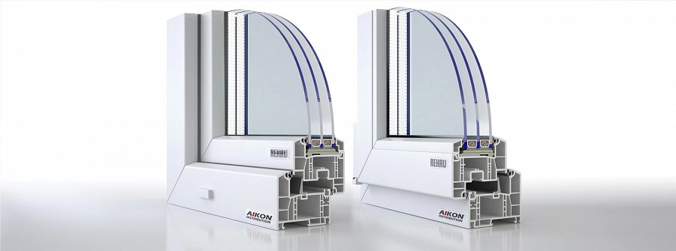

This means that the windows we are talking about here and now are able to modfiy the way heat circulates between your house and the rest of the world, namely - the closest environment.

This means that they are able to keep most of that heat in, instead of allowing it to run out of your house.

**What's the effect of it?**

This is a solution and an effect that's very much useful now - since it means that less and less energy needs to be produced and therefore, there are two - at least! - effects.

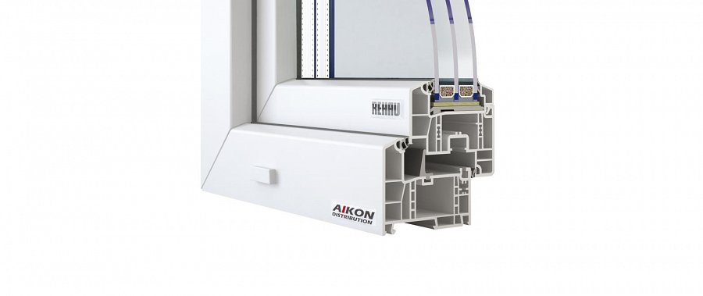

First of them is lowering the cost of the energy that needs to be produced in order to keep the house in a good thermal condition. This is what *Rehau Geneo* windows can do for you. Apart from that, there is also the green aspect to it - meaning that the environment will be less of put at risk because of individual energy needs.

<https://www.aikondistribution.com/geneo-md,p39>