**Veka PVC | www.aikondistribution.com**

**Veka PVC windows is an offer made by Aikon Distribution - it's us - supplier and distributor of selected, finest products for houses - windows and doors. Wanna know more? Keep reading...**

**Veka PVC windows for all**

Veka PVC window connects three features important when you need to choose a product. From one side, it's the quality. We guarantee that the paramteres of **Veka PVC** are satisfying.

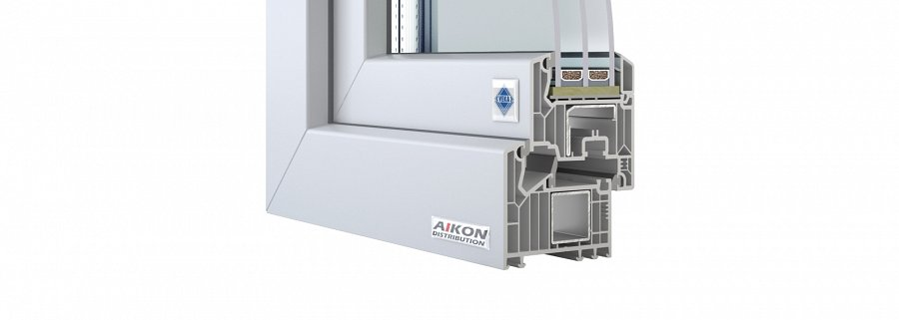

From another, perspective, it's aesthetics - elegance is the first word that comes to mind, when you look at those windows. The cost is the last one - last, but not least important. And when it comes to the product in question, it's competetive and affordable.

**About the technical details...**

About the window technology itself, the presented Effectline model of *Veka PVC* windows are classified as Class A. For them to be rated A, they needed to have the walls thick as much as 3mm. So they do have.

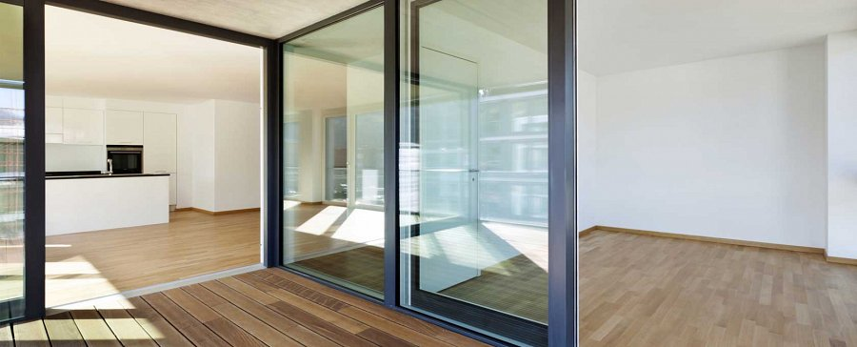

Thanks to the construction, the robust production standards, Veka PVC windows prevent heat loss and noise from outside to get in. Also, they are more resistant to mechanical damage.

Why wait more, then? If you want to look more closely at the pictures and see the section of the window's frame, visit the website of Aikon Distribution: [Veka PVC](http://bit.ly/veka-pvc)