**HPL door - let's decipher...**

**Intersted only in the finest? And at the same time, strongly interested in diverse materials that can guarantee that your door will stay strong and serve your house for a long time into the future? HPL door is something worthy to pay attention to.**

**HPL door...? Let's decipher it**

HPL door are door panels made of so called high pressure laminate. And the basis of the material, of the laminate here is high reactive resins and paper.

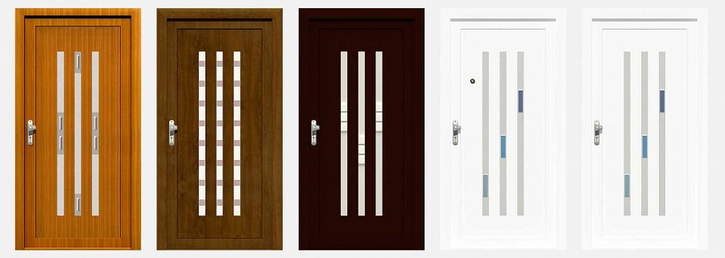

Together, as the name suggests itself, pressed in very precise conditions, they create a material which has several advatanges, making it perfect for serving as a door panel material.

What are those advantages, precisely for *HPL door* panels? Well - low thermal expansions is one thing. Another is mechanical durability and mechanical strength is another - and those qualities alone, as fundamental, should suffice for making the door look interesting to all of you looking for a really good products.

**What else can you get from us?**

From Aikon Distribution, there are several additional perks. Such as cutting the **HPL doors** to custom size free of charge. Also freely you can feel, choosing the thickness of the panels - from 24mm to 48mm as max.

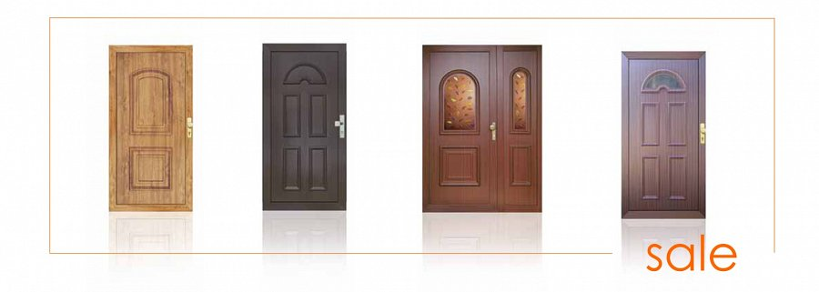

More about HPL doors you can read here:

[www.aikondistribution.com/sandra,p235](https://www.aikondistribution.com/sandra,p235)